**DBMS LAB ASSIGNMENT 5**

**🡪 Using the tables created previously generate the SQL statements for the operations mentioned below. The tables in user are as follows:**

**a. Client_Master**

**b. Product_Master**

**c. Salesman_Master**

**d. Sales_Order**

**e. Sales_Order_Details**

**• Perform the following queries on the tables mentioned above :**

**Q1. Find the ProductNo and description of non-moving products i.e., products not being sold.**

**Answer :**

select sales_order_details.ProductNo,

description from sales_order_details , product_master

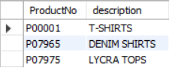 where QtyDisp = 0 and sales_order_details.ProductNo = product_master.ProductNo;

**Q2. List the customer Name, City, and PinCode for the client who has placed the order no ‘O19001’.**

**Answer :**

select NAME ,CITY , PINCODE from client_master

where ClientNo = all (SELECT ClientNo from sales_order where OrderNo = 'O19001');



**Q3. List the client names that have placed orders before May’04.**

**Answer :**

select name from client_master

where ClientNo in ( select ClientNo from sales_order where OrderDate < '2004-05-01');

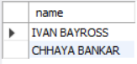

**Q4. List if the product ‘Lycra Top’ has been ordered by any client and print the Client_no, Name to whom it was sold.**

**Answer :**

SELECT ClientNo , name from client_master

where ClientNo in (SELECT ClientNo from sales_order

where OrderNo in ( SELECT OrderNo from sales_order_details

where PRODUCTNO in (SELECT PRODUCTNO from product_master where DESCRIPTION = 'Lycra Tops')));

**Q5. List the names of clients who have placed orders worth Rs. 10000 OR MORE.**

**Answer :**

select name from client_master where clientno in (select clientno from sales_order

where odereno in (select orderno from sales_order_details group by orderno having sum(productrate)>10000));

**Q6. Retrieve the city of every customer whose name starts with ‘I’.**

**Answer :**

select city from client_master where name like "I%";

**Q7. Fid the name, Address1, city , pin code and YtdSales of the salesman who have higher YtdSales than the employee whose name start with letter ‘O’.**

**Answer :**

SELECT salesmanname,address1,city,pincode from salesman_master

where ytdsales>= all(select ytdsales from salesman_master where salesmanname like"O%");

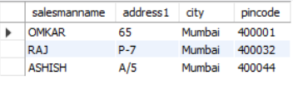

**Q8. Find the name and city of the client who have more than 1 orders.**

**Answer :**

SELECT name,city from client_master

where clientno in (select clientno from sales_order

where orderno in(select orderno from sales_order_details where qtyordered>1));

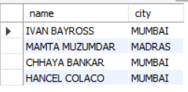

**Q9. Find the description and product number who’s total qtl ordered is less than 25.**

**Answer :**

SELECT descrip,productno from product_master

where productno in (select productno from sales_order_details where productno in

(select productno from sales_order_details group by productno having sum (qtyordered) <25));

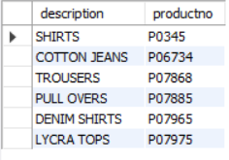

**Q10. Find the description, sell price and cost price of the products whose**

**Answer :**

SELECT description , sellprice,costprice from product_master as p where p.productno

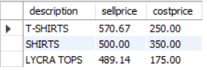in (select productno from sales_order_details as s where productrate<1200);

**Q11. Find the status of the orders of those clients who belongs to Maharashtra.**

**Answer :**

SELECT * from sales_order_details

where orderno in (select orderno from sales_order

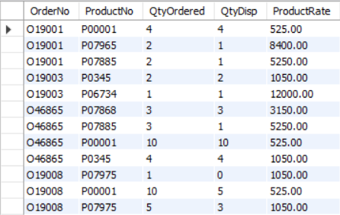where clientno in (select clientno from client_master where state='MAHARASHTRA') );

**Q12. Calculate the profit for each product.**

**Answer :**

SELECT (profitpercent/100)*costprice from product_master;

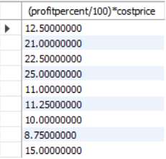

**Q13. Find the total number of orders placed for Karnataka state.**

**Answer :**

SELECT count(orderno) from sales_order

where clientno in (select clientno from client_master where state="Karnataka");

**Q14. Find the name, address1 and address2 of the salesman whose order of status is either in process or fulfilled.**

**Answer :**

update sales_order set salesmanno="S00002" where orderno="O19002";

update sales_order set salesmanno="S00001" where orderno="O19003";

update sales_order set salesmanno="S00004" where orderno="O19008";

update sales_order set salesmanno="S00003" where orderno="O46865";

update sales_order set salesmanno="S00002" where orderno="O46866";

select salesmanname,address1,address2 from salesman_master where salesmanno in

(select salesmanno from sales_order where orderstatus in('In Process','Fulfilled'));

